Free at Last
Civil Rights in the USA
1918-1968
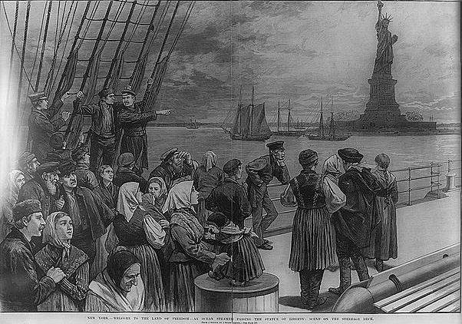
Sourcebook 1 –
Immigration

Lesson 1 – The Attraction of America
Source 1 – taken from the Intermediate 2 workbook
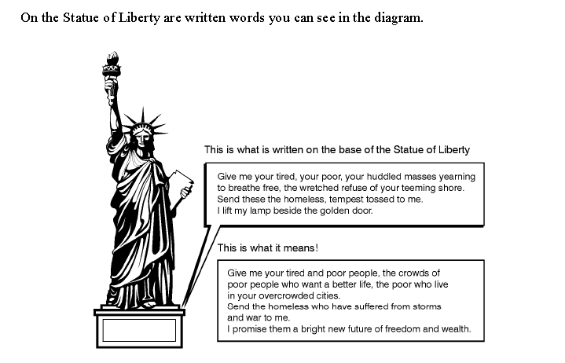
Source 2 was written by a man who landed in America in 1920.
I left Italy to make money. If I could have made money in Italy I would have stayed there but I couldn’t. I was told America is the land of opportunity so I came here.

Source 3 is a poster used in the USA in the 1930s.

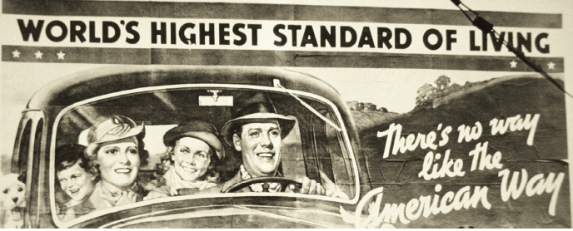

Sources 4 – 11 are from the Intermediate 2 pack

Source 4

American industry and business led the world. The USA had industrialised rapidly in the 19th century. The economy was still growing fast and employers needed a constant supply of labour. There were also good opportunities to set up new businesses.

Source 5

Wages for skilled trades and those working in large factories were better than in Europe. A farm worker in the USA could expect to earn far more than he could in Europe and would be able to buy his own farm.

Source 6
Many people were persecuted in their own countries, for political or religious reasons. For example, in the late nineteenth century, thousands of eastern European Jews faced attacks called ‘Pogroms’. These were especially bad in Russia.

Source 7 Source 8

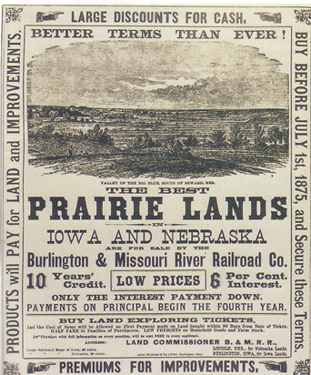
Increases in population in Europe meant that many areas were overcrowded. There was a shortage of land and younger children in large families could not expect to inherit much when their parents died.
1- A poster encouraging immigrants to come to America

Source 9

Some wanted to go to America because they believed that they would be free to practise their religion, and live their lives as they wanted. The American Bill of Rights had guaranteed freedom of religion and freedom of speech.

Source 10

America had massive natural resources – oil, timber and minerals. Land was cheap, and there was plenty of space to expand.

Source 11

Many workers, both skilled and unskilled, found themselves out of work in Europe. There were various reasons for this; for example, economic depression or the introduction of new machinery that replaced farm workers.
Source 12 – from official immigration statistics

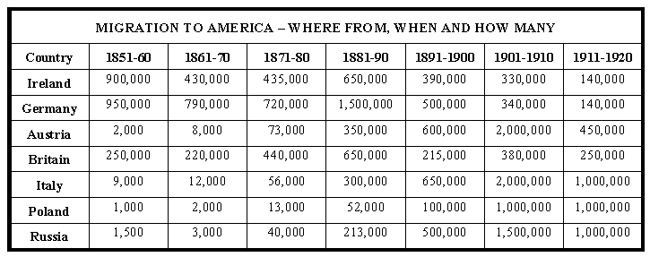

Source 13 – from history.com
Ellis Island opened in 1892 as a federal immigration station, a purpose it served for more than 60 years (it closed in 1954). Millions of newly arrived immigrants passed through the station during that time--in fact, it has been estimated that close to 40 per cent of all current U.S. citizens can trace at least one of their ancestors to Ellis Island.

Source 14 – from history.com
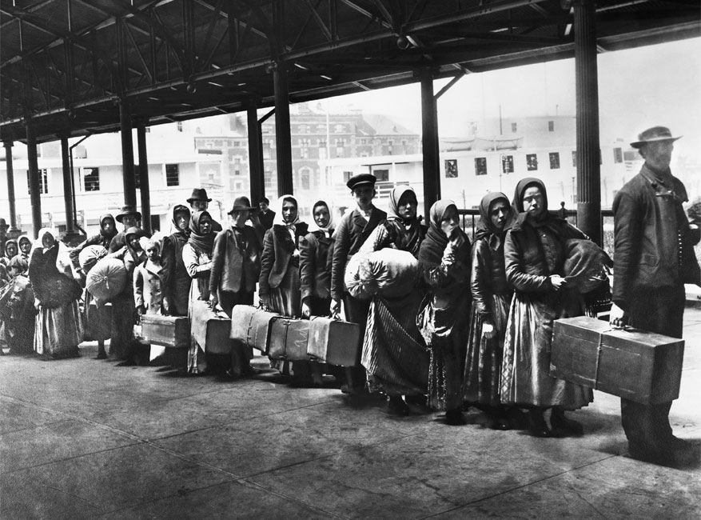
After a difficult and dangerous sea voyage, many passengers caught their first glimpse of New Jersey, while third-class or steerage passengers lugged their possessions onto barges that would take them to Ellis Island. Immigrants were tagged with information from the ship's registry and passed through long lines for medical and legal inspections to determine if they were fit for entry into the United States. From 1900 to 1914--the peak years of Ellis Island's operation--some 5,000 to 10,000 people passed through the immigration station every day. Approximately 80 per cent successfully passed through in a matter of hours, but others could be detained for days or weeks.

Source 15 – from the Intermediate 2 pack
Every immigrant was inspected by the doctors. The doctors viewed them from above to watch for weakness, heavy breathing (indication of heart problems) and other signs of mental disturbances.
When each immigrant passed, the doctor, with the help of an interpreter, examined the hair, face, neck and hands of every person. The doctor had a chalk in his hand, and when he noticed that some area needed to be checked more thoroughly, he wrote a letter on the immigrant’s clothes. About 2 of every 10 people got a letter on their clothes. This check became known as "the six second physicals".
What did the letters mean?
X - mental defects.
X within a circle - some definite disease.
B - back problems
H - heart problems
Pg - pregnancy
Ct - eye disease
Lesson 2 - The Problems facing Immigrants
Source 1 – A definition of the American Dream.
In the late 19th century and early 20th century the great flow of immigrants which arrived in America were attracted by promises of a bright and wealthy future. Immigrants believed in the American Dream. The American Dream meant that everyone, no matter who they were or where they came from, had the same chance of success if they worked hard.
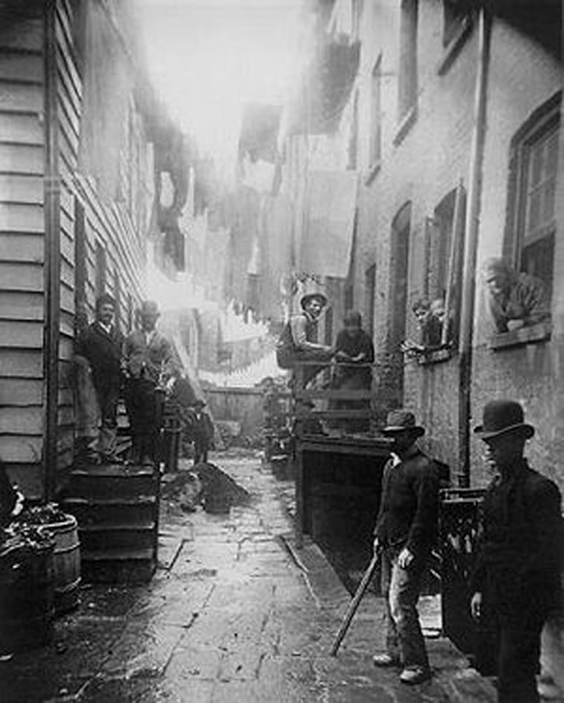
Source 2 –
Figure 2 - A New York slum
By 1920 most Americans were living in towns. The flood of immigrants looking for homes and work meant that cities grew quickly. There was little control over the buildings or the conditions. A very serious problem faced by immigrants to the USA were the slums that grew up in the overcrowded cities. Slums became overcrowded, diseases such as cholera spread easily and crime was common.
New York had the worst slums because it was the city that most immigrants poured into. All immigrants had to be checked at Ellis Island just offshore from New York so naturally New York was the first place new immigrants looked for homes.
Source 3 -
Housing conditions were terrible and so were working conditions and that wasn’t surprising. Houses and work places were the same place! It is not unusual to find lots of people, from young children to old people, at work in the dirty rooms, sewing, stitching, making clothes to sell in the market stalls or repairing watches and clocks. Anything that would raise a few dollars.

Source 4 – an account taken from a Russian immigrant

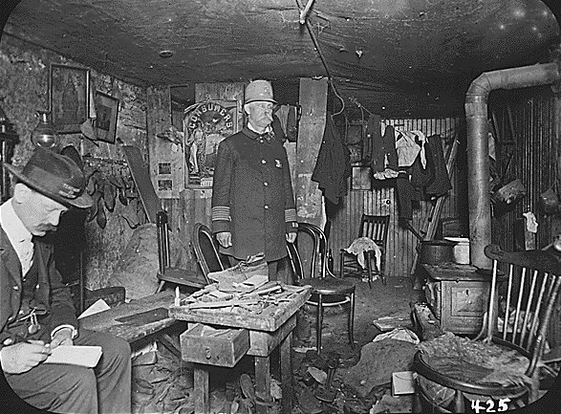
Apartments had no heating. In five years thirty-two people in our block had died from breathing problems brought on by the lack of heating and the damp rooms we lived in. Running water was only available in the filthy hall. Toilets were in the basement, about 10 floors down from our room. The smell was terrible and in winter we froze. But we froze back in Russia so what’s the difference? At least now we had a dream to aim for.

Source 5 –Intermediate 2 pack

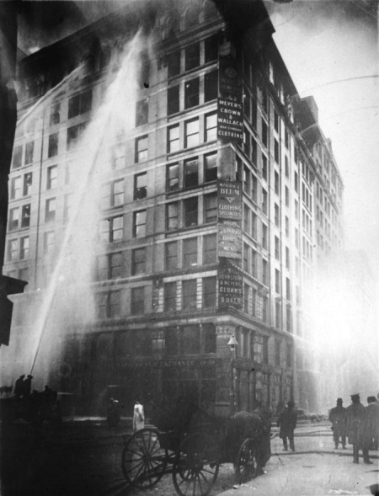
Most industries offered hazardous conditions and very low wages--lowered further after the padrone (a ‘boss’ who found work for immigrants) took out his share. Urban housing was overcrowded and unsanitary. Many found it very difficult to accept. An old Italian saying summed up the disillusionment felt by many: "I came to America because I heard the streets were paved with gold. When I got here, found out three things: First, the streets weren't paved with gold; second, they weren't paved at all: and third, I was expected to pave them." In spite of the difficulties, few gave up and returned home.
Figure 3 - Inside a New York tenement
Figure 4 - a fire in a New York factory

Source 6
New York was not the only place scarred by the immigrant slums. Slums could be found wherever immigrants settled. With such bad conditions it’s hardly surprising that so many tried to escape by making easy money. Every block had its gambling dens, its prostitutes and its gangsters. Immigrant crime is a threat to the American way of life.

Lesson 3 – The Status of America’s Ethnic Groups

Source 1 - Thomas Jackson, politician, 1920
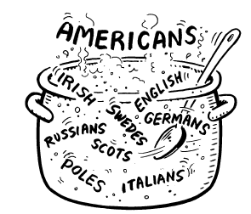
The motto of the USA is ‘E Pluribus Unum’ which is Latin for ‘Out of many comes One’. Although America is made up of people from all over the world I hope that the different groups will mix together to become American - in other words from lots of different people one type of person - an American - will emerge.

Source 2 – Woodrow Wilson, American President

America is like a huge melting pot. It is here we will mix the races together to create a new person - an American.

Source 3

The phrase ‘salad bowl’ was used to describe an America in which many immigrants tried to keep their old cultures alive so that they were American but still had their roots in their old countries.

Source 4 -

We all had our own areas of the city. We called our area Little Italy. We were safe there coz all us Italians lived there. Just round the block there was Little Poland and Little Russia. We spoke and ate and sang and prayed just like we had back home and we were free to do that. America was the land of the free.

Source 5

‘Old immigrants’ does not mean people who are old. The phrase means people who had lived in the USA for several generations. These ‘old immigrants’ thought they were important because they had made money and because their ancestors had arrived in America a long time ago. They despised the ‘new immigrants’ who had only just arrived in America and were poor. People were also judged on where they came from. Old immigrants had mostly come from countries in Northern Europe such as Britain, Ireland, Germany or Scandinavia. A very important word to know is WASP. You’ll see what it means in the diagram. Old immigrants were usually WASPs. WASPs thought they were better than everybody else. The most successful people in America in the early 20th century were usually WASPs.

Source 6 –
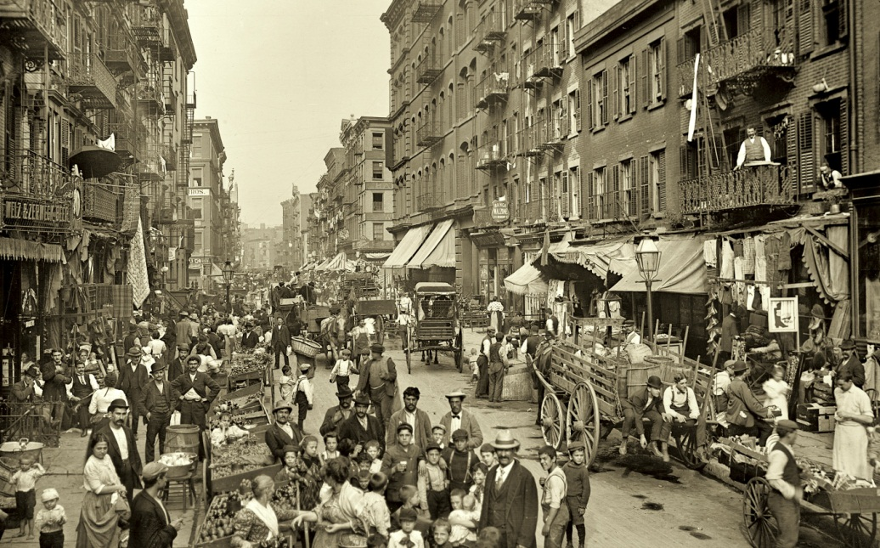
As in many other places in the world, Italians in America clustered into groups related to their place of origin. For example, the Neapolitans and Sicilians settled in different parts of New York, and even people from different parts of Sicily settled on different streets. However, what seldom occurred in the U.S. was all-Italian neighbourhoods.
Figure 5 - Little Italy
By 1920, the Little Italies had stabilized and grown considerably more prosperous as workers were able to obtain higher-paying jobs, often as skilled workers. English was now the language most commonly heard on the streets of the Little Italies.

In politics, Al Smith (Ferrara) was the first Italian American governor of New York, and a candidate for president in 1928. Fiorello LaGuardia became mayor of New York City in 1931.

Source 7 –

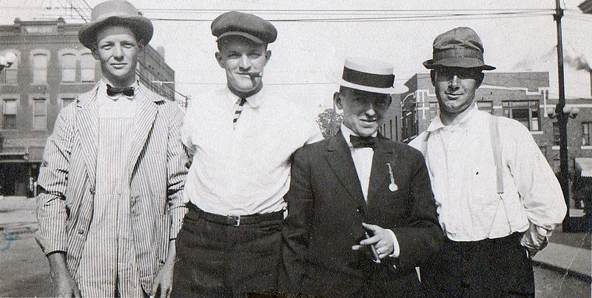
Most Irish immigrants to the United States during this period favoured large cities because they could create their own communities for support and protection in a new environment. Cities with large numbers of Irish immigrants included Boston, Chicago and New York. In 1910, there were more people in New York City of Irish heritage than Dublin's whole population.
Figure 6 - Irish immigrants

The first generations worked largely at unskilled and semiskilled occupations, such as miners and labourers, but their children found themselves working at increasingly skilled trades. Two jobs commonly done by Irish-Americans were policing and the fire service.

Irish Catholics were popular targets for stereotyping in the 19th century. The media often stereotyped the Irish in America as being violent, voting illegally, prone to alcoholism and dependent on street gangs that were often violent or criminal.

Source 8 –
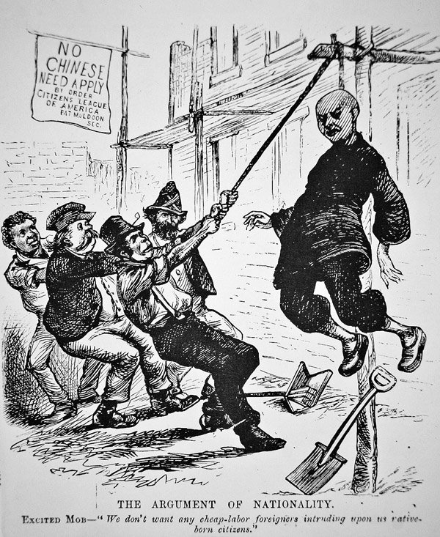
Figure 7 - an anti-Chinese cartoon (1880)

Immigrants were not always European. Many immigrants were Mexican and Oriental. Mexicans had moved north from Mexico trying to escape poverty and war in their own country. Mexicans suffered in three ways. They were Catholic, ‘new’ immigrants and had a coloured skin.

Orientals were people from Asia, especially countries such as China and Japan, who moved to the USA to find jobs like building the railways. By 1900 the railways had been built and there was strong prejudice in the USA against ‘yellow’ people. Immigration was stopped by the Chinese Exclusion Act of 1882. This act outlawed all Chinese immigration to the United States and denied citizenship to those already settled in the country.

Source 9 –

Another group which suffered unfair treatment were Native Americans. They are called this because out of the whole population of America they were the only people who are ‘natives’ and are not descended from immigrants. During the 19th century, Native Americans were persecuted and pushed off their land. By 1900 they lived on reservations which were areas of land the white government allowed them to live on. The Native Americans had been defeated in wars with the US government.
Today Native Americans believe that the USA government had a policy of genocide in the late 19th and early 20th century.

Source 10 –

At the bottom of society were the blacks. Until the middle of the 19th century most black people in the USA had been slaves. After the 1860s slavery was stopped but life was still very hard for most black people in the USA. They were the largest of the racial minorities and had few rights. Blacks were discriminated against in schools, work and in law. Most blacks lived in poverty but as the American economy grew, many saw their chance of a brighter future by moving north to the big industrial cities. So they began to migrate within the USA. They were also looking for the American Dream.

Source 11 – Tommy Dawkins, a black teenager in 1923

In Los Angeles we had a swimming pool in our neighbourhood. The pool was cleaned on a Friday. From Saturday until Monday the white kids played in it. On Tuesdays the Mexican kids played in it. On Wednesday the Chinese and Japanese kids played in it and just before it was cleaned on a Friday we got to swim in it. I guess they thought the dirty water wouldn’t show up on us.

Extension – Article from the Daily Mail, 2013

A truly captivating map that shows the ancestry of every one of the 317 million people who call the melting pot of America home can now be seen on a U.S. Census Bureau map. For decades, the United States opened its doors and welcomed with open arms millions of immigrants who all arrived through New York's Ellis Island in the hope of a better life in America. Indeed, the inscription on the Statue of Liberty in New York’s harbour reads 'Give me your tired, your poor, your huddled masses yearning to be free' and the fascinating map identifies the truly diverse nature of the United States in the 21st century. Although the 2010 census left out questions about ethnicity, this map shows how it looked in 2000.

49,206,934 Germans
By far the largest ancestral group, stretching from coast to coast across 21st century America is German, with 49,206,934 people. The peak immigration for Germans was in the mid-19th century as thousands were driven from their homes by unemployment and unrest.

The majority of German-Americans can now be found in the centre of the nation, with the majority living in Arizona and according to Business Insider. Famous German-Americans include, Ben Affleck, Tom Cruise, Walt Disney and Henry J. Heinz

Germans were attracted to America for familiar reasons, open tracts of land and religious freedom and their contributions to the nation included establishing the first kindergartens, Christmas trees, hot dogs and hamburgers.

41,284,752 Black or African Americans
The census map also identifies, Black or African-American as a term for citizens of the United States who have ancestry in Sub-Saharan Africa. The majority of African Americans are descended from slaves from West and Central Africa and of course have become an integral part of the story of the United States, gaining the right to vote with the 15th amendment in 1870, but struggling with their civil rights for at least another century. Predominantly living in the south of the nation where they were brought to work on the cotton plantations and as slaves in the late 18th to mid-19th centuries, Black or African Americans also have sizable communities in the Chicago area of Illinois and Detroit, Michigan.

35,523,082 Irish
Another group who joined the great story of the United States were the Irish and the great famine of the 1840s sparked mass migration from Ireland. It is estimated that between 1820 and 1920, 4.5 million Irish moved to the United States and settled in the large cities like New York, Boston, Philadelphia, Chicago and San Francisco.

Currently, almost 12 per cent of the total population of the United States claim Irish ancestry – compared with a total population of six and a half million for the Republic of Ireland and Northern Ireland today. Irish residents of note include John F. Kennedy and Neil Armstrong and 35,523,082 people call themselves Irish.

26,923,091 English
The next largest grouping of people in the United States by ancestry are those who claim to be English-American. Predominantly found in the Northwest and West, the number of people directly claiming to be English - American has dropped by 20 million since the 1980 U.S. Census because more citizens have started to identify themselves as American. They are based predominantly in the northeast of the country in New England and in Utah, where the majority of Mormon immigrants moved in the middle 19th century.

17,558,598 Italian
One of the most influential nationalities to migrate in large numbers to the United States were the Italians.
Between 1880 and 1920, more than 4 million Italian immigrants arrived in the United States forming 'Little Italies' wherever they went. Bringing their food, culture and entertainment to the nation, another large wave of Italian immigrants arrived in the country following WWII, bringing the total number today to 17,558,598 people.

9,739,653 Polish
The largest of the Slavic groups to live in the United States, Polish Americans were some of the earliest
Eastern European immigrants to the New World. Up to 2.5 million Poles came to the United States between the mid-19th century and World War 1 and flocked to the largest industrial cities of New York, Buffalo, Cleveland, Milwaukee and Chicago.

Lesson 4 – Changing Attitudes to Immigration

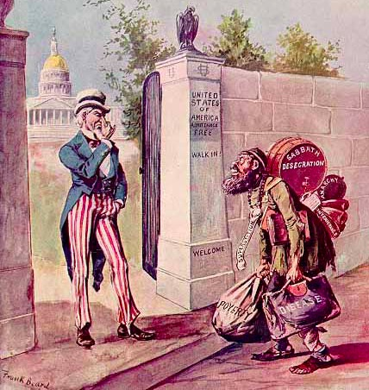
Source 1 –

Racism and prejudice were important reasons for wanting to limit immigration. For many older Americans, especially the WASPs, it was not so much the increased numbers of immigrants which worried them, but the changes in the type of immigrant that arrived in the USA.

In 1911, a government inquiry called the Dillingham Commission concluded that immigration from southern and eastern Europe posed a serious threat to American society and culture and should therefore be greatly reduced.

Source 2 –

The so-called "Red Scare" refers to the fear of communism in the USA during the 1920s. It is said that there were over 150,000 anarchists or communists in USA in 1920 alone and this represented only 0.1% of the overall population of the USA.
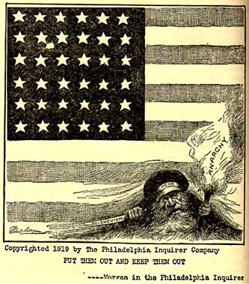
However many Americans were scared of the communists especially as they had overthrown the royal family in Russia in 1917 and murdered them in the following year. In 1901, an anarchist had shot the American president (McKinley) dead. Many new immigrants from Eastern Europe were accused of bringing communism and anarchism with them.
The fear of communism increased when a series of strikes occurred in 1919. The police of Boston went on strike and thousands of steel and coal workers did likewise. The communists usually always got the blame.
A series of bomb explosions in 1919, including a bungled attempt to blow up America’s Attorney-General, lead to a campaign against the communists. On New Year’s Day, 1920, over 6000 people were arrested and put in prison. Many had to be released in a few weeks and only 3 guns were found in their homes. Very few people outside of the 6000 arrested complained about the legality of these arrests such was the fear of communism. The judicial system seemed to turn a blind eye as America's national security was paramount.
Communism = Communism is an economic theory that everyone owns everything. They do whatever they can, and in return everyone receives what they need.
Anarchism = A belief that government is wrong and that people should be free to govern themselves.
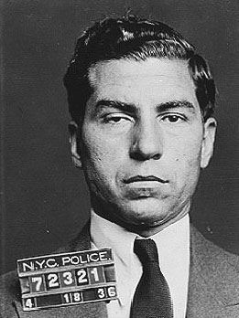
Figure 8 - Lucky Luciano
Source 3 –

During the 1920s Prohibition era, when alcohol was banned in America, Italian-American gangs (along with other ethnic gangs) entered the booming bootleg liquor business and transformed themselves into sophisticated criminal enterprises, skilled at smuggling, money laundering and bribing police and other public officials. The Mafia in the U.S. and Italy were separate, although the Americans adopted some Italian traditions, including omerta, an all-important code of conduct and secrecy that forbid any cooperation with government authorities.

In the late 1920s, a bloody power struggle known as the Castellammarese War broke out between New York City’s two biggest Italian-American criminal gangs. In 1931, after the faction led by Sicilian-born crime boss Salvatore Maranzano came out on top, he crowned himself the “capo di tutti capi,” or boss of all bosses, in New York. Unhappy with Maranzano’s power grab, a rising mobster named Lucky Luciano had him murdered that same year. Luciano then masterminded the formation of a central organization called the Commission to serve as a sort of national board of directors for the American Mafia, which by then consisted of at least 20 crime families across the country. New York, which had become America’s organized-crime capital, had been divided into five main Mafia families; everywhere else the Mafia operated, there was just one crime family per city.
Source 4 –
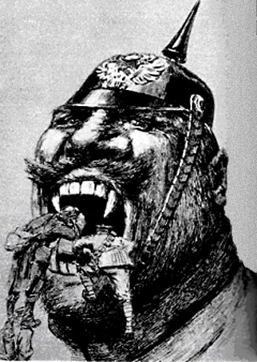
World War One was also a reason. Most Americans had accepted the ‘melting pot’ idea that all new immigrants would become ‘Americans’ but during the war many German immigrants supported the German side in the war and when the USA joined the war against Germany there was a danger that American society would be split.
City streets in Chicago with German names were changed. The German food sauerkraut came to be called ‘liberty cabbage’, hamburgers became ‘liberty sandwiches’, German measles became ‘liberty measles’ and frankfurters became ‘hot dogs’.
Furthermore, as many German immigrants were involved in brewing (Budweiser), they were held responsible for alcohol ruining America’s way of life. Finally, after the war, many Americans wanted to stay out of Europe’s problems (isolationism), and did not want fresh immigrants bringing ‘European problems’ to America.

Source 5 - from a letter to the New York Times in 1922
America for Americans I say. There’s enough people here already. Since the war there’s been growing unemployment. Why should I lose my job to a new arrived immigrant who can’t speak the language or live next door to folk who ain’t American? Keep ’em out, at least until the folks here get a better life.

Source 6 - Report by US Labour Union leaders, 1918

In 1916 US Labour Unions agreed that the basic survival wage for a worker should be $745 a year but the average pay received by Italians and Hungarian immigrant labour was $400 a year. Any action taken by our unions to improve conditions and wages for workers has failed because the bosses employed Italians and Poles to break the strike.

