The Atlantic Slave Trade
1770 -1807

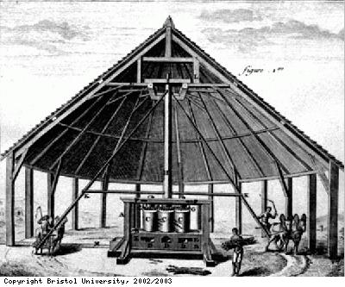

Sourcebook 3
Britain and the Caribbean

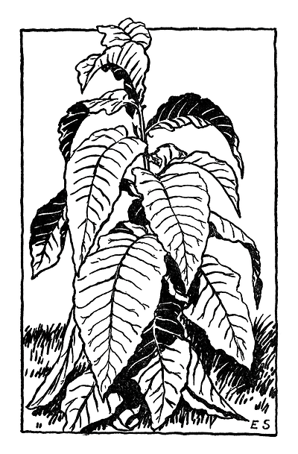
Lesson 1 – Sugar and the Caribbean
Source 1 –Decline of tobacco in the Caribbean
The Caribbean, unlike Virginia, did not benefit from the rise of tobacco harvests. The farming economy in the British West Indies was based on the growing of tobacco and faced a severe crisis. For one, Caribbean tobacco could not compete with the production of tobacco in America. Since the Caribbean’s economy had once thrived and depended on tobacco farming for financial sustainability, they were rapidly losing population. However the Dutch had introduced sugar cane to the West Indies. Huge sugar cane plantations were established.
Source 2
Tobacco grew much better on the mainland of America in states such as Virginia. In 1775 however the tobacco trade collapsed with the outbreak of the American Wars of Independence. In Scotland profits made from tobacco were invested in other industries.
Source 3 –
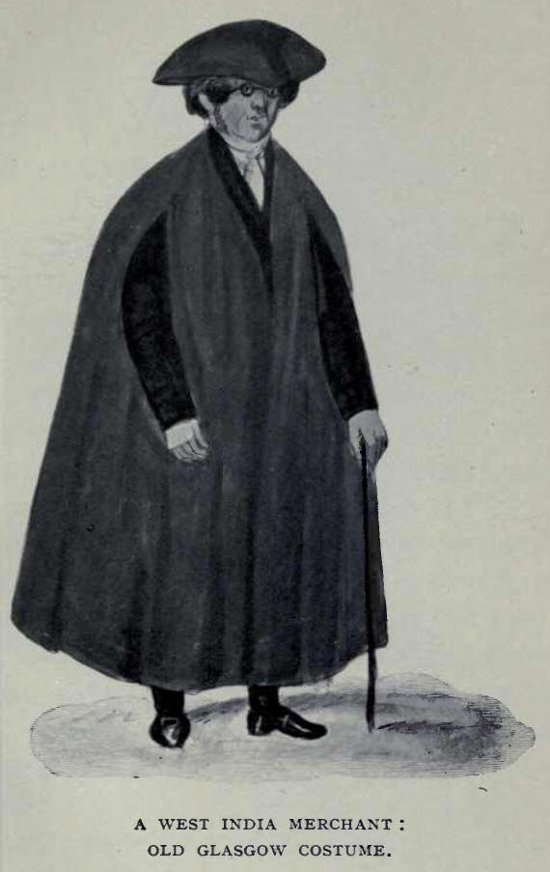
The Tobacco Lords adopted their own style of dress; a scarlet cloak over breeches and coat, silvered wig, tricorn hat and silver-topped ebony cane. They are most popularly described as strutting along the Trongate, the first fully paved street in Glasgow, to which they seem to have claimed sole use.

Source 4 - from Josephine Kamm, ‘The Slave Trade’
Before planting canes, the land had to be made ready by burning and clearing away the grass. Rows of holes were then dug in which the new canes were planted. The base of each cane had to be covered with earth and then covered again regularly as the cane grew. The growing canes also had to be weeded constantly.
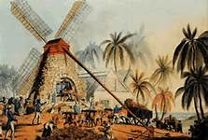
Source 5 -from James Walvin ‘The Slave Trade’
……once the cane was cut it had to be turned into crude sugar. It was crushed boiled and distilled in a rough and often dangerous process which was as hard a task as working in the cane fields.

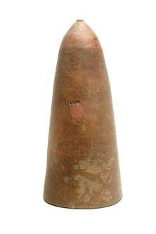
Source 6 - Sugar mould on display at the Dockland Museum in London
Molten sugar would be poured into the mould and shop keepers would cut off a piece from the sugar cone for their customers.

Extension Article from the International Slavery Museum in Liverpool
Sugar cane takes 14 to 18 months to mature Cane grows best in the wet months from June to November and ripens in the dry months of January to May. Planters staggered cultivation so that the cane did not all mature at once. The cane was planted either by digging a trench and lying old cane cuttings end to end, or by digging holes and inserting cuttings of cane two feet long. A gang of thirty enslaved Africans using hoes could plant two acres in a day. The cane was fertilised with animal manure. When the cane was ripe, the enslaved workers cut the sugar cane by hand with broad curved machetes and loaded the stems onto carts. Mills were slow and inefficient so during the harvesting season the slaves worked in the mill and boiling house 24 hours a day to process the crop. “During crop time they work night and day almost incessantly”, wrote Revd William Smith in 1745.

Plantation owners built sugar works on their estates to process the cane. Once the cane was cut, it needed to be processed quickly or the juice the cane contained would ferment and spoil. The cut sugar cane was brought to the mill by donkey or cart. Inside the mill, the enslaved workers fed the cane through wooden or metal rollers to crush it to extract the juice. The earliest mills, known as cattle mills, were powered by cattle, mules or oxen. Windmills were brought in gradually during the 18th century. They worked faster than animal mills, but were useless when the wind dropped so some owners kept animal mills in reserve.

From the mill the raw cane juice was channelled to the boiling house, where it flowed into clarifiers - large metal pans. Here lime and ashes were added to the juice and it was heated to remove impurities. The juice was then ladled into the first of a series of five or more large metal basins called 'coppers' (although in fact usually made of iron), which were heated to drive off the moisture. The juice was heated and moved successively down the line of coppers, progressively reducing and thickening.

Making sugar was a highly specialised process. It was critical to know the precise moment when the sugar was ready to set. The boiler, a highly skilled slave, would test the sugar with his elbow or by rubbing the hot sticky syrup between the fingers. His was one of the most important jobs on the plantation and a skilled boiler was a valuable slave.

Lesson 2A – Sugar and Scotland
Source 7 – Alexander Grant of Dalvey
Alexander Grant (1705–1772) studied basic pharmacy at Aberdeen, before sailing to Jamaica at age 17 to make his fortune. He started work as a doctor to the slaves on sugar plantations owned by his cousins, but within ten years he had bought his own plantation and opened a trading enterprise in Kingston. In 1737 he married Elizabeth Cooke, daughter of a wealthy plantation owner from Bristol. In 1739 they left Jamaica to settle in London, where Grant continued to expand his business, including the slaving venture at Bance Island and contracts with the Royal Navy. In 1752 he bought the estate of Dalvey near Forres, Morayshire. He was MP for Inverness Burghs from 1761 to 1768. When he died in 1772 his fortune included six estates in Jamaica, which totalled almost 7,000 acres and held 457 slaves.
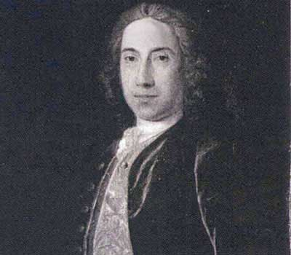
Source 8 Richard Oswald of Caithness
Figure 1-Oswald
Richard Oswald was born in Scotland in 1705 to the Reverend George Oswald of Dunnet. When Oswald died in 1784 he left an estate worth £500,000, including Auchincruive in Ayrshire and a trading empire controlled from his office in London. He also owned a fort and slave trading station on Bance Island (now known as Bunce Island) just off the coast of Sierra Leone. Here he sold slaves and made a huge amount of money.
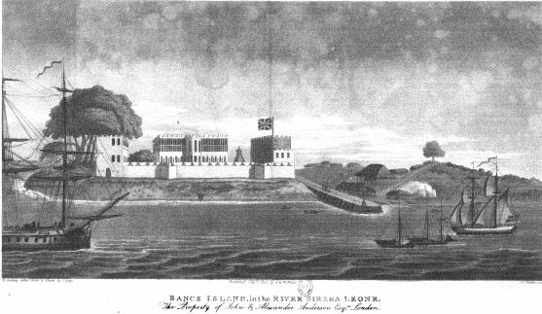
Source 9 –
Hundreds of young men from Scotland went to Britain’s slaving colonies hoping to get rich. Many were skilled tradesmen or highly educated professionals who faced unemployment at home.
Jonathan Troup was one of them. A medical graduate Aberdeen, he sailed to Dominica in 1788 as an assistant to Dr Andrew Fillan. Fillan was one of many doctors from Scotland working in Dominica. These medical men were making fortunes.
Source 10 –
In 1796, Scots owned nearly 30 per cent of the estates in Jamaica and by 1817, a staggering 32 per cent of the slaves. Many Scots masters were considered among the most brutal, with life expectancy on their plantations averaging a mere four years.

Lesson 2B – Impact of the Sugar Trade on the Caribbean
Source 11 - From Jamaican Gleaner ‘Pieces of the Past’
A typical sugar estate was 900 acres. This included a Great House where the owner or overseer and the domestic slaves lived. There was accommodation for the bookkeeper, distiller, mason, carpenter, blacksmith, cooper and wheelwright. With the exception of the bookkeeper by the middle of the eighteenth century the jobs were carried out by skilled black slaves.
Source 12 – A sugar estate in Barbados
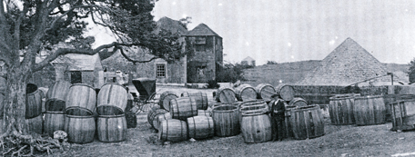
Source 13 - The impact of the slave trade on Jamaica.
The impact can be divided up into two main factors long term and short term. In the short term the native (indigenous) people, the Arawaks were wiped out and then replaced by West Africans. As a result of the increasing number of slaves the Europeans were outnumbered and lived in fear of rebellion. The only way to control this was thought to be a harsh system of physical punishments, some for relatively minor offences for example playing a drum.
When the Jamaicans stopped growing tobacco and grew sugar only for export this made the islands dependent on the price of sugar. If prices fell the economy would collapse. Another long term legacy was a sense of injustice felt by the people of the Caribbean.

Lesson 3 – London and Finance
Source 14
How Extensive and Profitable Was the Slave Trade for Britain?
In 1770 100,000 slaves were carried to America. In 1790 74,000 ships carried slaves.
British | 38,000
French | 20,000
Portuguese | 10,000
Dutch | 4,000
Danish | 2,000

Source 15 by historian Dr Hakim Adi
It is impossible to think of the modern city of London without considering its involvement with the enslavement and trafficking of African captives. Modern London grew rich and prospered as a result of Britain’s involvement in the Atlantic slave trade from its earliest beginnings in the 16th century.
All the major institutions in London from the Bank of England to the National Gallery and British Museum are closely connected with the money generated by this great crime against humanity.
Source 16
London was a major port sending slave ships to Africa and the Americas and handling and processing most of the sugar and other slave-produced goods imported into the country. It was for this purpose that the West India docks were constructed. It was also the financial centre of the trade and the economies it supported in the Caribbean.
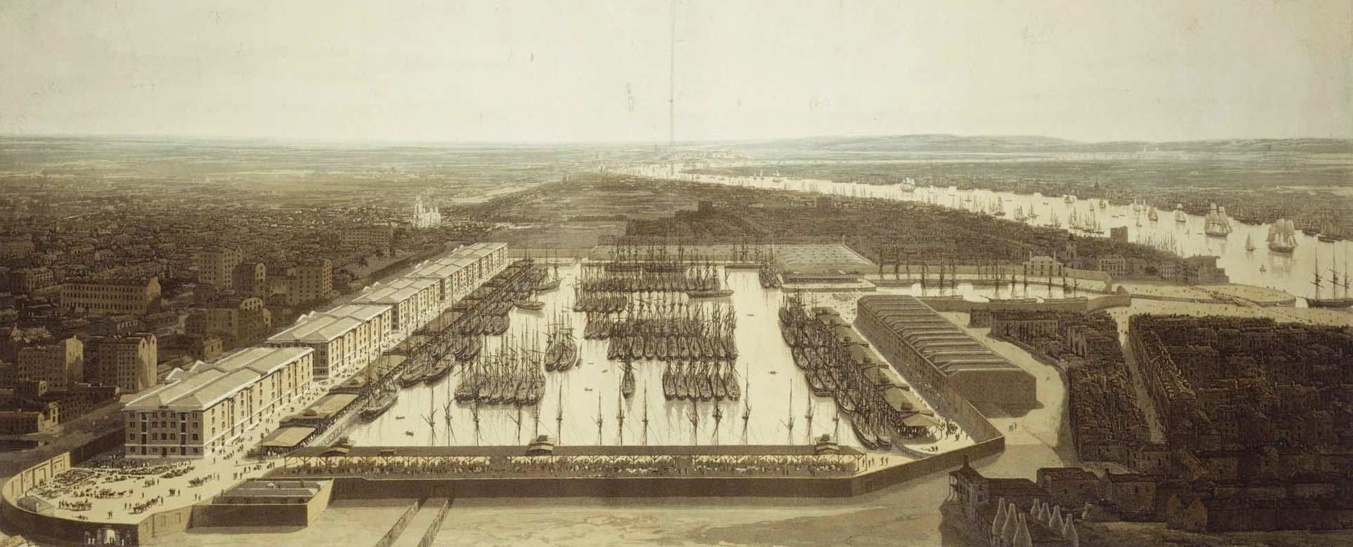
In the 18th century wealthy Londoners, such as the major slave owners William Codrington and William Beckford, were able to buy their way into high office and control of parliament. The wealth they made from slavery was important in helping to make them MPs.
Source 17
A number of Londoners closely involved with the Atlantic slave trade developed their businesses in this prime location. For example, Ambrose Crowley, an iron merchant, produced manacles and irons for tethering slaves on ships. John Angerstein, a Blackheath merchant and founder of Lloyd's of London, owned estates in Grenada. The Pett family, master shipbuilders in Deptford, built many of the ships that were involved in the Atlantic trade. Woodlands from their estate provided timber for their shipbuilding business.
Source 18
If you look at the cost of fitting out a slaving ship you will see that large sums of money were required. Ship owners insured their ships against loss i.e. if the ship sunk then the insurance company would pay out the cost of the ship and contents. In 1745 an Insurance Act was passed that said that you could not insure a ship for more than it was worth.
Source 19 - the money required to fit out a slaving ship
In the 18th century a person could earn about £35.00 a year or about 65p a week.
Cost of fitting out a ship | £26,151
Cost of cargo | £8,896
Total costs | £35,047
Sales of slaves | £41,475
Profit | £6,428
Source 20
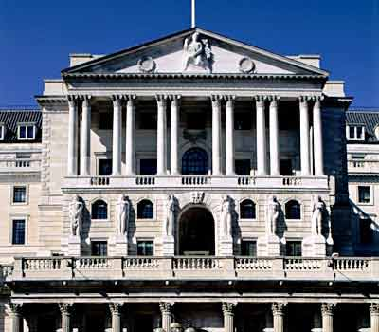
There were no banks in the City until the mid-17th century, and even a century later, banking was under-developed outside London. But slave traders and planters badly needed credit. A slave voyage from Liverpool to Africa then on to the Caribbean, before heading home, could take 18 months. And each point of the trade - buying and selling Africans, buying and importing produce (mainly sugar) cultivated using the labour of enslaved people - involved credit arrangements. Merchants and traders in London, Bristol and Liverpool, bought the planters' produce, so in effect, British merchants became the bankers of the slave trade.

Source 21
In 1762, John Baring’s three sons established the London merchant house of John & Francis Baring & Co, later known as Baring Brothers. This house traded with other merchants, buying and selling commodities and other goods in British and overseas markets. It also acted as London agents for overseas merchants, arranging shipping and insurance, and making and collecting payments. This led on to financing the trading activities of these merchants. This means the bankers lent money to the plantation owners to buy slaves and equipment. When the sugar was sold the plantation owners would then pay back the debt (with interest). This banking business was a mainstay of the firm’s work from the eighteenth until well into the twentieth century.
Source 22
The origins of Lloyds Bank date from 1765, when button maker John Taylor and iron producer and dealer Sampson Lloyd set up a private banking business in Dale End, Birmingham. The bank began business in a London coffee house. It grew into a very successful business based on profits made from the slave trade. Barclays Bank also has its roots in the slave trade. It was set up by David and Alexander Barclay to provide loans to slave merchants.

Lesson 4 – The Impact of the Slave Trade on Industry and Navigation.
Source 23
The British iron industries boomed on the back of slavery - chains, padlocks, fetters, the metal used in ship construction and hundreds of thousands of firearms that were shipped to West Africa to exchange for African slaves. In addition, all the tools used on the slave plantations were manufactured in Britain.
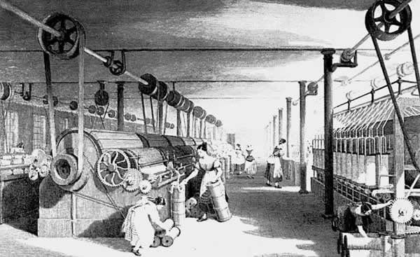
Source 24
Raw cotton, from slave plantations, picked by unpaid labour, was imported from across the Atlantic, to be transformed into cloth in Manchester's factories. Some was sold in Britain, but some, particularly brightly coloured textiles, were loaded on to ships bound for Africa to be exchanged for slaves. By 1770 one third of Manchester textiles were sold to the African market.

Source 25
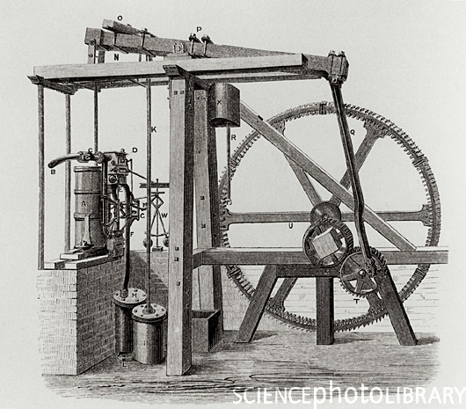
The Triangular Trade helped other British industries. Birmingham alone exported 100,000 muskets a year to Africa, most of them exchanged for slaves. Sugar refining became a major industry in Britain. The wool and cotton industries got a massive boost, both from the import of the raw material from the West Indies, and from the new markets for the export of their finished goods.

Entrepreneurs also expanded the economy by ploughing back profits from slavery into their own industries in Britain. James Watt, for example, depended on money made from the West Indian trade to finance the development of his new invention, the steam engine. Money made by slave traders from Bristol played a key role in the construction of the Great Western Railway.

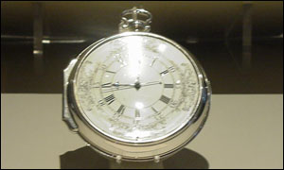
Source 26- John Harrison and longitude from BBC news March 11th 2001.
The longitude problem - how a ship could know how far west or east it had sailed from its home port - was perhaps the hardest of the 18th Century.
John Harrison was a working class joiner who developed an obsession for creating high-precision clocks. John Harrison believed that there was a mechanical answer to the longitude problem and after working on the problem for forty years, proved that a clock could be used. In six weeks his clock was out by just five seconds; an accuracy three times better than that required to win the £20,000 prize. Harrison was an old man of 79 when, in 1772, he finally received the recognition, and prize money, he deserved, after King George III intervened on his behalf.

